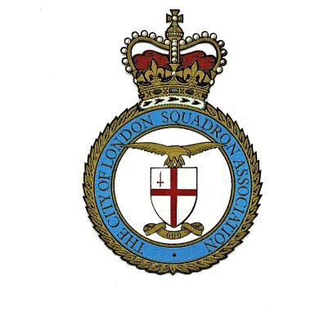
HOME DEFENCE 1940-1942 BATTLE of BRITAIN 1940 SICILY 1943
SALERNO
FRANCE and LOW COUNTRIES 1940
NORTH AFRICA 1942-1945 ANZIO and NETTUNO
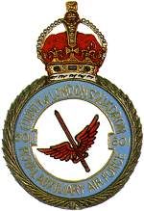
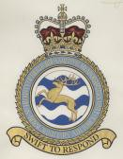
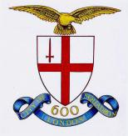
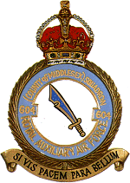
THE
CITY OF LONDON SQUADRON ASSOCIATION

PRINCIPLES AND POLICY

The objectives of the Association are to:

- Support by collective or individual endeavor all undertakings of the Squadron.

- Honour the memory and carry on the work of those who die in the service of their Country.

- Encourage the bond between present and past, and maintain the traditions of the Squadron.

- Promote the welfare of all members and their spouses, widows, widowers and other dependents.

The Association provides continuity in co-operation with

Our Sister Squadron and Unit and their Associations
No. 2600 (City of London) Field Squadron, Royal Auxiliary Air Force Regiment No. 1 (County of Hertford) Maritime Headquarters Unit

Our Affiliated Squadrons and its Associations
No. 21 (City of Melbourne) Squadron, Royal Australian Air Force Reserve No. 601 (County of London) Squadron, Royal Auxiliary Air Force.
No. 604 (County of Middlesex) Squadron, Royal Auxiliary Air Force.

THE CITY OF LONDON SQUADRON ASSOCIATION

- “Where there are two Englishmen there will be three gardens because the Club will have a garden”….was the description by an anglophile of the English – and so with 600 Squadron. Soon after the war, those who had been in the flux in welding our team, which built the enduring and growing heritage, expressed a desire to renew old friendships and enjoy again the comradeship with the Squadron whose life as a family had been disrupted by the war.
- In 1946, the Auxiliary Air Force was re-established and No. 600 Squadron was re-formed. On 16th December 1947, His Majesty The King granted the title Royal Auxiliary Air Force, and the highest tribute was paid not only to the Squadrons but also to the men and women volunteers of the Auxiliary Air Force who dispersed to give of their ability to units of all Commands at home and overseas and moreover to the handful of regulars who had with patience and understanding trained them. To the present generation of the Squadron, it provided an incentive by re-organising those who are willing to give voluntary service and train themselves in arms not to attack or subdue others but to defend the heritage we all share.

- By unanimous vote to a General Meeting held in the Drill Hall at T.H.Q. Finsbury Barracks, the Association was inaugurated on Friday 2nd October 1953, when rules that had been drafted by a Ways and Means Committee appointed at a Reunion on Friday 29th May 1953, were approved.

- Through its Committee, the Association has Reunions, some for members only, others for members and their spouses and partners. The audited accounts are presented at the AGM when the annual election of a Committee takes place. A bulletin to recapture the past and record the present keeps all members in touch.

- Members are as far afield as Australia, New Zealand, Canada, the United States of America, South Africa, Zimbabwe, Switzerland, France and Eire.

- We are fortunate in the number of friends, men and women, service and civilian who, although not serving members of our Squadron, give help and incentive by their constant interest in our fortunes. We are happy to be able to invite them to keep in touch through Associate Membership and enjoy all that the Association has to offer.

- An Association such as ours entails much voluntary work but if its members are to be served a sound financial position is essential. In order to ensure that no one is precluded from membership for financial reasons, effective March 2015 an annual subscription has been set at £5 per annum. However, it is hoped that every member will make an annual donation in accord with his means and fortunes, vary as they may from time to time.

- It may be your desire to join but there is also a duty you owe to your friends who worked alongside you and are interested in your life and fortunes, to whom a means of keeping in touch affords much pleasure.

- If you, or your dependents, are ever in need of help, every assistance that your Association can give is there for the asking: even in a welfare State as we know it today, there is still room for voluntary organisations such as ours.

FOR OUR MUTUAL BENEFIT

- The Honorary Secretary would be glad of the names and addresses of those who are eligible but not yet members.

- The reverse of the application form is blank. Please write more of your service life, experiences, or other details, which will help in knowing you better and ensure that the Association really is a family concern.

- Cheques should be made payable to The City of London Squadron Association.

EXTRACTS FROM THE RULES

RULE 4 – MEMBERSHIP
  - Every Officer, NCO and Airman serving on the posted strength of the Squadron will ipso facto be a member of the Association.
  - An Officer, NCO or Airman of the Regular, Reserve or Auxiliary Air Forces who served on the posted strength of the Squadron or its sisters, 2600 Sqn and 1MHU, is eligible for membership.
  - The Committee by majority vote may invite as an Associate Member a civilian or member of the services.

RULE 5 – ELECTION OF MEMBERS
- Each candidate for election to membership shall apply to the Membership Secretary on the Approved application form.
- The election of members is vested in the majority vote of the committee whose decision is final and who shall not disclose their deliberations.

RULE 7 – SUBSCRIPTION
- Subscription is set at £5 per annum. Donations are always gratefully received and will be faithfully applied.
- No subscription shall be paid by serving members of the Squadron or by Honorary or Associate Members.

